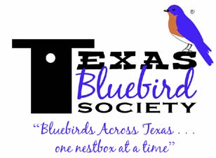 | 2014 Season Kickoff  (with Silent Auction FUNdraiser) |  | 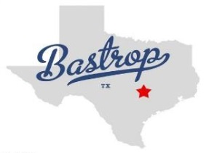 |  |  | ADVANCE Registration (includes Box Lunch)  On-line registration available at register.texasbluebirdsociety.org  Registrant #1  Name Name for Name Tag  Street Address City  State Zip  Contact Phone E-mail  Registrant #2 (same street address)  Name Name for Name Tag  Contact Phone E-mail  # Registrants (Please circle) Description Cost New $15 Membership at this event includes FREE nestbox! Do you plan to join at the meeting? Y N (This is not a firm commitment for membership. Please do not send membership dues now.)  1 2 Member $15.00  1 2 Non Member $15.00  1 2 Friday Night Dinner $15.00  □Check □Cash Total Due:  To register more attendees, please include an additional sheet with your mailing.  For Planning Purposes Only  - TBS Members and New Members: TBS will give you a FREE nestbox at this event if you pledge to “NestWatch” at least 2 nestboxes (submit observations to Cornell Lab of Ornithology through www.nestbox.org).  Do you plan to participate? ❑ Yes ❑ No ❑ N/A  - $15 Nestboxes available for purchase (based upon availability). How many do you plan to purchase?  Mail Registration Form with Payment made payable to “Texas Bluebird Society” to:  Texas Bluebird Society Season Kickoff P O Box 40868 Austin, TX 78704 STANDARD Registration—Deadline Feb 15, 2014 AT-THE-DOOR Registration available (no lunch or door prize chances) Register now with your SmartPhone  Website
Saturday, March 1, 2014
Bastrop Convention Center, 1408 Chestnut Street, Bastrop, TX 78602
9:00 AM–3:00 PM
Doors open at 8:30 for Registration and Silent Auction
Featured Speakers  Robyn Bailey, Cornell Lab of Ornithology, NestWatch  Dr. Patricia A. Gowaty, (via Skype) UCLA, world’s foremost bluebird researcher  Other Presentations: Bluebird Basics, House Sparrow Control, Native Plants, & more  Registration Costs and Deadlines  Advance Registration: $15.00. Box Lunch and 2 Door prize tickets.  Deadline: February 15th |  |  |  | 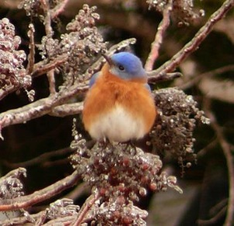  photo by Bill Lindemann
At-the-door Registration: $6.00. No meal and no door prize tickets.
Friday Evening Social with Presentation on Chimney Swifts by Paul and Georgean Kyle
$15 at Hampton Inn. Buffet at 7 PM. Happy Hour at 6 PM Happy Hour BYOB (donations for Margaritas). Deadline: February 15
Lodging: Hampton Inn $99.00 (single or double). Ask for the Texas Bluebird Society group rate. (512) 321-2898
Deadline: Jan. 28
On-line registration available at http://RSVPbook.com/2014Kickoff
FREE Nestbox to members who pledge to “NestWatch” at least two nestboxes
(submit observations to Cornell Lab of Ornithology through www.NestWatch.org)

To Donate a Silent Auction Item:*  Benni Konvicka  1315 North Dale Ave  Stephenville,TX 76401-1604  auction@texasbluebirdsociety.org  (254) 968--6663  Donations received after February 15th will miss the publication deadline.  *TBS is recognized by the IRS as a 501c3 ”charitable” organization. Donations are tax deductible, as allowed by law. |  | For More Information:  pauline@texasbluebirdsociety.org  512 268-5678
 |  | 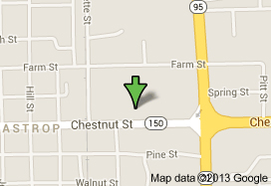 |  |  | Bastrop Convention Center  1408 Chestnut Street

