Native Plants for Bluebirds
Mistletoe - Phorandendron leucarpun
(member of the Viscaceae family)

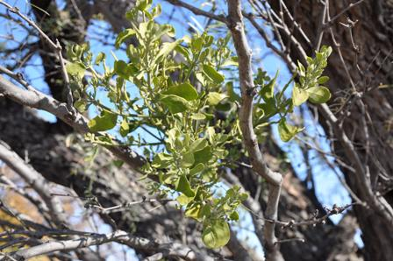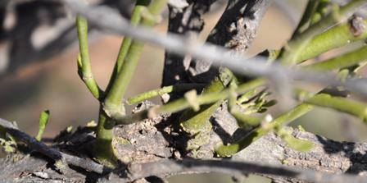
Mistletoe Plant Mistletoe growing into Mesquite branch

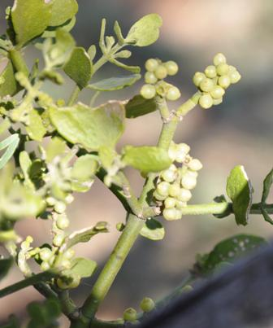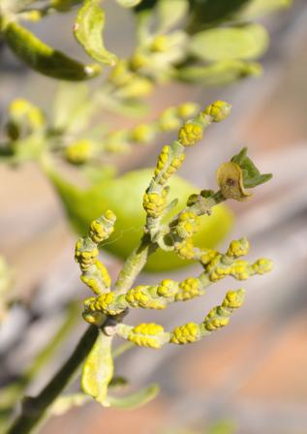
Mistletoe Berries Mistletoe Flowers Photos by Judy Hetherington

Mistletoe is a semi-parasitic plant that grows on mesquites, junipers, hackberries and other deciduous trees across Texas. The flowers are clusters of tiny yellow flowers on smooth, green, jointed stems. The word “mistletoe” could have been derived from German; Mist for dung and Tang for branch. This derivation refers to the fact that mistletoe is spread in the feces of birds.

Various varieties of mistletoe can be found in Europe, Great Britain, US and Australia. All varieties have pairs of evergreen leaves that are ovoid with smooth edges. While mistletoe “feeds” on the host tree, it may only slow the growth of the tree. If the infestation is heavy, however, it can kill the tree (and itself).

The Lady Bird Johnson Plant Database describes mistletoe as follows:

This is the common Mistletoe hung at Christmastime. The genus name derives from the Greek phor a thief, and dendron a tree, and refers to their getting at least some nourishment from the trees on which they grow. The fruits are covered with a sticky substance poisonous to man, but relished by such birds as cedar waxwings and bluebirds. The birds spread the seeds through their droppings and by wiping their beaks on branches, where a new plant may become established.

While often considered a pest that kills trees and devalues natural habitats, Mistletoe has recently been recognized as an ecological keystone species, an organism that has a disproportionately pervasive influence over its community. A broad array of animals depend on mistletoe for food, consuming the leaves and young shoots, transferring pollen between plants, and dispersing the sticky seeds. A study of mistletoe in junipers concluded that more juniper berries sprout in stands where mistletoe is present, as the mistletoe attracts berry-eating birds which also eat juniper berries. Such interactions lead to dramatic influences on diversity, as areas with greater mistletoe densities support higher diversities of animals. Thus, rather than being a pest, mistletoe can have a positive effect on biodiversity, providing high quality food and habitat for a broad range of animals in forests and woodlands worldwide. (Source Wikipedia)

Mistletoe is on the TBS list of “Texas Native Plants that Provide Food* for Eastern Bluebirds”.
*Berries.

Submitted by Judy Hetherington

